DigiRAMP Mobile

Enjoy Music with your friend



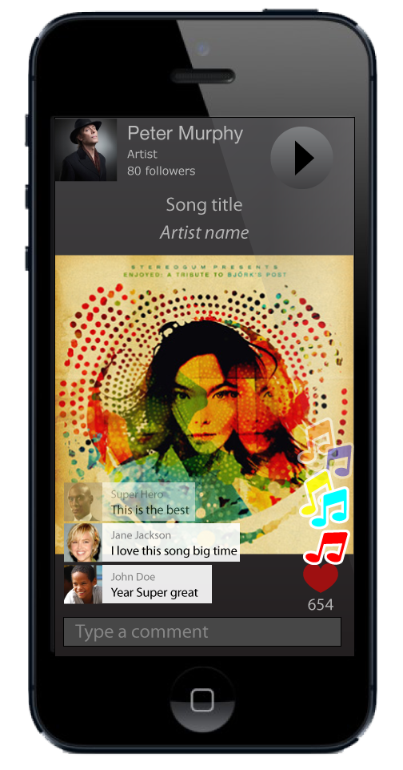

Table of content

About this document 4

What it is 5

A Mobile APP 5

What it does 5

How it works 5

What it’s good for 5

Who is it for 5

Use cases 6

Alone streaming 6

One to One, Live 6

One to many, Live 7

Streaming 8

Share it with social networks 8

Technology 9

Streaming storage 9

Data Base 9

Switch board 9

Administrative backend 9

Widgets 9

Apps 9

The space 10

Musixmatch 10

Linkfire 10

YouTube 10

Spotify 10

Valuation 11

Intellectual property 11

Technology readiness 11

Revenue streams 11

Mobile market 13

Growth hacking 13

Future applications 13

# About this document

The product proposed in this document is a media player for mobile devices.

The purpose is to give users and experience of listen to music together with friends.

It can be in a live concert situation or a more personal experience like ‘let me play a song for you’ and everything in-between.

I’m not diving in to permission of media usage, payments and royalties. I simply assume content owners want their media used, whatsoever the DigiRAMP backend is used for collecting of user metrics, commerce, administration and delivery for more information this request information about DigiRAMP.

Neither am I describing the media player interface Social features and search engine. This I leave for a detailed SDK and the UX documentation.

I’m also just briefly touching possible revenue streams at the end of the document. The core value should come from tree things related to an exit strategy

1. Intellectual protection
2. Significant user base and B2B deals
3. Technological implementation

Max Grønlund

# What it is

First of all it’s a shared experience. You can get it on Facebook, Youtube, or on any Media player that supports the DigiRAMP API. That could be Spotify, Pandora, iTunes etc. Before I explains that lets look at the mobile app.

## A Mobile APP

At the core it’s a dead simple media player and a social network. Where it brings unique value to the table is: It’s enables users to interact in real time in a way previously know from concerts and ‘face to face’ interaction. It also enables influencers and curators to make money by providing recommendations and playlists.

## What it does

When playing a media file users can socialize with each other in real time by posting super small messages and applause by taping the screen or shaking the phone.

All users can watch each other’s input. This can be in real time and recorded as a list of events that appears at the same position on the media during playback, The media can be provided in real-time or as a live stream.

## How it works

Unlike a normal media player the app sends information’s to a backend serve every time any user interacts with media.

This information’s is then merged recorded and pushed back to all online users.

## What it’s good for

* Users get unique shared experience
* Artists get feedback

## Who is it for

* The Audience
* DJ’s
* Artists
* Curators
* Bands
* Individuals
* Events in general

# Use cases

## Alone streaming

Joe finds a song and start to play it. Then he can see comments posted by other users floating up over the song. When he posts his own comment it’s stored with the song; next time someone plays it the comment is shown, he can also applause on passages he likes and the applauses are stored with the song.

## One to One, Live

Joe wants Josephine to hear a song

He finds Josephine in his connections and invite to listen to the song

Josephine receives a 'growl notification' saying 'John wants to play a song for you'

She clicks on the message and now she sees the graphics that goes together with the song.

John can see Josephine went online and he starts the song.

Now Josephine can hear the song and she can type small messages that pops up over the song

When there is parts of the song she really like she taps the screen or shakes the phone to applause

John can see what Josephine comments and applauses and Josephine can se johns



## One to many, Live

A band is playing live. They want all their fans to engage in the concert

They have announced the concert on DigiRAMP all their friends and followers on social media. Facebook. Twitter. LinkedIn has been notified.

Fans there have signed up for the event receives a notification before the event start.

During the event they can follow it from the app and interact with the audience

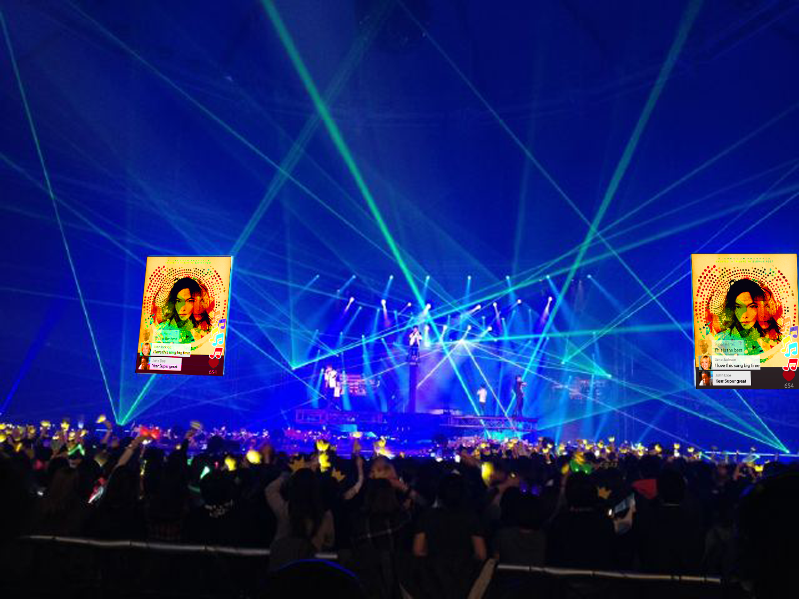

Feedback and suggestions I have received

* Projected interaction on big screens.
* Let audience pay for participating.
* It’s suitable for niche events
* It can be used for sponsored content regarding brands and events

## Streaming

DJ’s and curators can present better content when they can get feedback from the audience.

The engagement is not limited to individual media files but can easily be applied to streams as well.

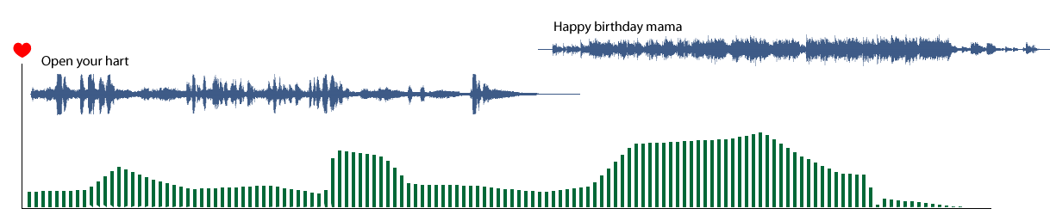

In the example above two songs is shown together with the applauses from the audience

## Share it with social networks

Facebook Google Twitter and YouTube all have nice API’s for integration and injection of data.

All content cleared for sharing can easily be embedded on the social platforms.

# Technology

DigiRAMP provides a many to many real time service.

The service is composed of the following key components

## Streaming storage

This is plain vanilla. And can be hosted on e.g. Amazon S3

## Data Base

The demands for the DB performance are higher than normal. Both Amazon and Google offer hosted solutions that can fulfill the needs

## Switch board

The implementation of this part is where DigiRAMP shines. This is where Patents and Intellectual property resides.

Optimization of CPU hungry elements is a part of the business model and also what bring costs to computers and electricity down.

## Administrative backend

This key component handle legal rights and payments to the respective owners and administrators

## Widgets

Integration with major social networks

## Apps

Native apps for various platforms

* iOS
* Android
* Windows
* OS X

Commerce engine

* Subscriptions
* Marked place

# The space

Is it done before? Absolutely no. Is it doable? Yes but it’s hard

## Musixmatch

Crowd sourced lyric and translations of known songs. Integrates seamless with YouTube true Google chrome plugin.

<https://www.crunchbase.com/organization/musixmatch#/entity>

<https://about.musixmatch.com/about/>

* $10.1M in 5 Rounds from 7 Investors
* 30+ employees
* HQ in Bologna, Italy
* Founded in January, 2010
* 40 million people using it worldwide to discover lyrics

Delivers Lyrics to Spotify and others through public API, free with a cap.

## Linkfire

Smart links for content providers, direct mobile users to their preferred shop and collect metrics for content providers.

social features.

* $2.72M in 2 Rounds from 2 Investors
* HQ in Copenhagen, Denmark
* 25 employees
* Founded in April, 2010
* Routed 35,674,942 Links

Notice. When it comes to collecting user metrics DigiRAMP is at current time ahead due to the

## YouTube

DigiRAMP can use same API and Google chrome plugin technology to offer similar integration as Musicmatch

## Spotify

DigiRAMP can offer curated playlists and popularity metrics through the same API as Musixmatch uses, Users with a Spotify account can also access content from Spotify through the DigiRAMP Player

# Valuation

There are different strategies for building value; they don’t exclude each other,

Value based on users.

Active users for startups are valuated in the array of 1-16$.

Forbes valuates a Twitter user is Worth $110; Facebook's $98; LinkedIn's $93

This depends on many parameters

* Growth rate
* Total number of users
* Loyalty
* Activity
* Revenue pr. User
* Potential revenue streams

## Intellectual property

* Patents
* Exclusive deals
* Deals
* Organization
* Source code
* Branding

## Technology readiness

* Ability to scale
* Low cost pr. User
* Deployment stack
* Code robustness
* Tests
* Security

## Revenue streams

There are potential revenue streams, not said all of them should be pursued but here are some

* Subscriptions
* Tickets to events
* Sponsored content
* Sales of metrics
* Paid for privacy

# 

# Mobile market

A few reasons for developing a mobile APP

* Two thirds of Soundcloud listeners comes from smartphones and tablets
* Streaming is suitable for mobile
* Better integration
* Spotify only works as APP
* The average smartphone user spend 3t 16m a day with the phone

# Growth hacking

<https://en.wikipedia.org/wiki/Growth_hacking>

* Push notifications
* Emails
* Signup with Facebook, Twitter, LinkedIn
* Flash usage on Facebook, Twitter, LinkedIn
* Grown notifications
* Hard to avoid inviting friends
* SMS verification, Notifications

# Future applications

When the infrastructure for mobile applications is in production spinoff products can be created for other kind of content that requires the same underplaying technology for administration and management of legal rights.

* Books
* Art
* Videos
* Healthcare